Game Design Document

Fill up the following document

1. Write the title of your project.

ROCKET SPACE

1. What is the goal of the game?

GOAL OF THIS GAME IS TO COLLECT THE STARS.

1. Write a brief story of your game.

IN THIS GAME I AM GOING TO CREATE A ROCKET IN THE SPACE WHICH WOULD COLLECT STARS AND WHEN THE ROCKET COLLIDES WITH ASTEROIDS THEN THE GAME ENDS.

1. Which are the playing characters of this game?

* Playing characters are the ones who respond to the user based on the input from the user.
* Cars, monkeys, dinos, wizards, etc., are the playing characters in the game.

|  |  |  |
| --- | --- | --- |
| Number | Character Name | What can this character do? |
| 1 | ROCKET | IT CAN COLLECT STARS AND COLLIDE WITH ASTEROIDS. |
| 2 |  |  |
| 3 |  |  |
| 4 |  |  |
| 5 |  |  |
| 6 |  |  |
| 7 |  |  |
| 8 |  |  |

1. Which are the Non-Playing Characters of this game?

* Non-Playing characters are the ones that don't have an action or behavior when the user interacts with the game.
* Hurdles, stones, bananas, coins, etc., are non-playing characters in the game.

|  |  |  |
| --- | --- | --- |
| Number | Character Name | What can this character do? |
| 1 | STAR | GENERATES RANDOMLY IN THE SPACE.  IT IS A POINT PROVIDER |
| 2 | ASTEROIDS | GENERATES RANDOMLY IN THE SPACE.  IT WILL END THE GAME. |
| 3 |  |  |
| 4 |  |  |
| 5 |  |  |
| 6 |  |  |
| 7 |  |  |
| 8 |  |  |

Draw your imagination of this game. What does this game look like?

* Draw the game either on your computer or on paper.
* Add images of the game scenes to show each of the playing and non-playing characters at least once.

PLAYING CHARACTER: ROCKET

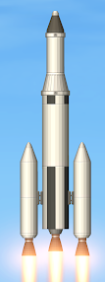

NON -PLAYING CHARACTERS:STAR



ASTEROID

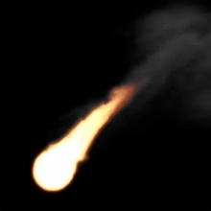

SPACE

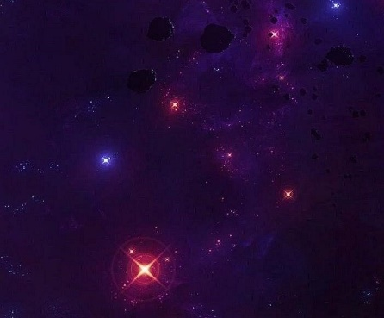

How do you plan to make your game engaging?

I AM MAKING MY GAME AS INFINITE SPACE GAME AND MAKING IT CHALLENGING BY GENERATING NON-PLAYING CHARACTERS RANDOMLY.AFTER SCORING FEW POINTS I AM INCREASING SPEED OF THE SPACE SO THAT IT CAN BECOME MORE CHALLENGING.